Title or Task: | Making a web page  

Description:

Files Required
Suitable for Classes: | AIT • Multimedia • Cert II IT • Cert II Bus
Area: | Technology & Enterprise
Teacher: | Mr Peter Faulks

Timeline

Date Due:

Task Brief:

Outcomes:

Items highlighted in yellow are tasks for you to complete
Items in Purple are help tips

Making a web page

Open your site Mysite Folder and index.html

Or
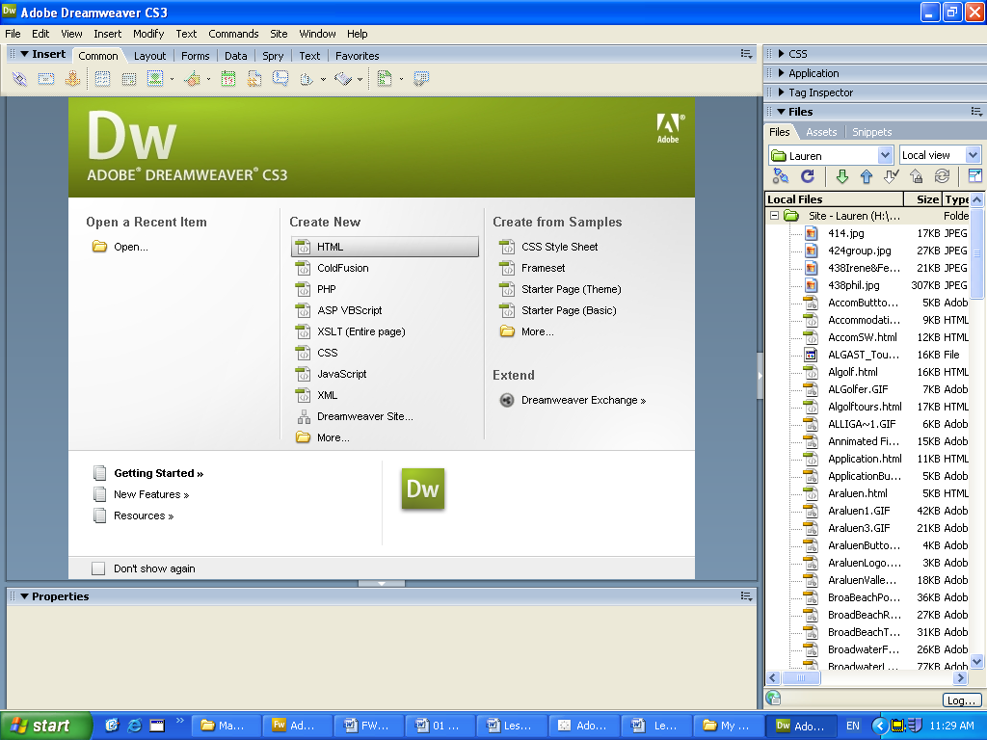
- Create a folder in your workspace called Mysite
- Create a folder inside this called assets
- Open Dreamweaver click on HTML as your site

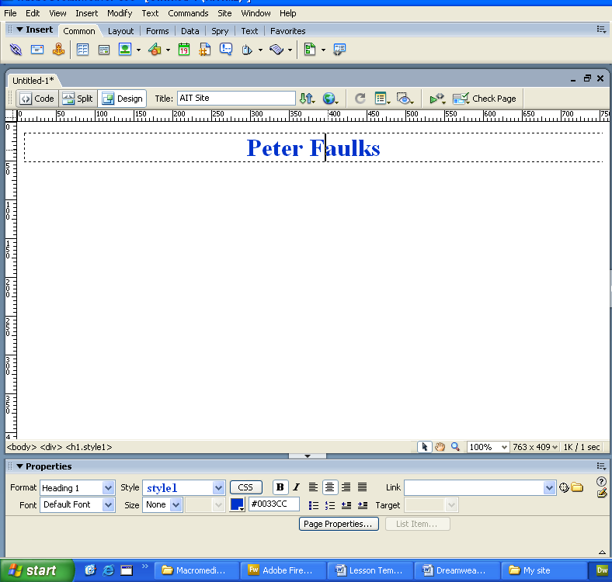
- Type your name , make it bold centred

- heading 1
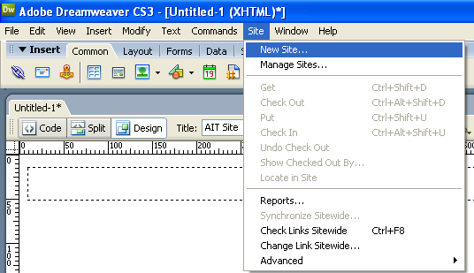
- Save the page as index.html

- Open site New Site…

- Name it MySite

- Click on the folder for the root location

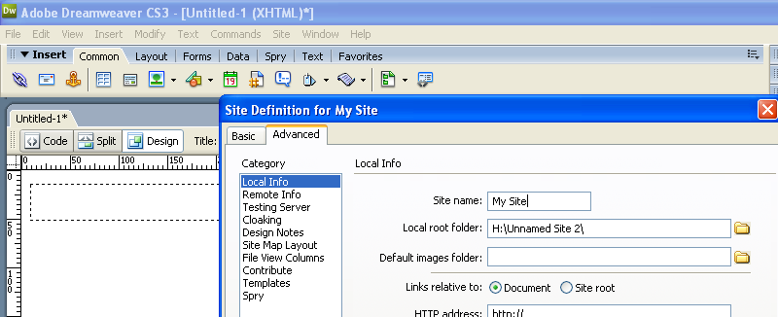

- Track to your folder My Site

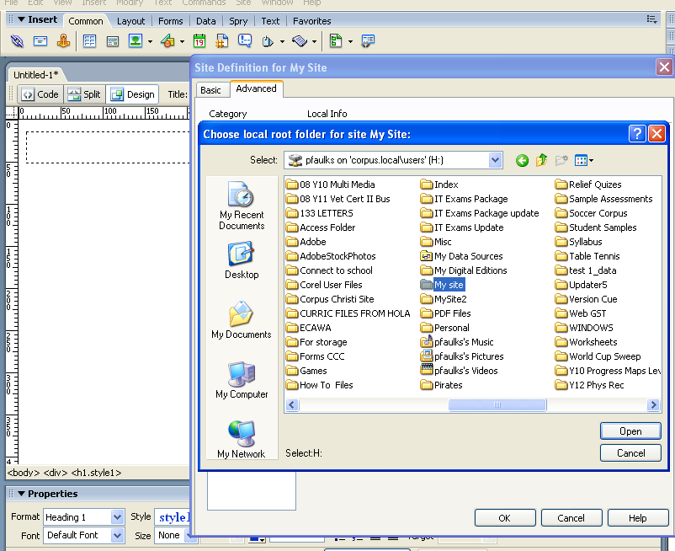

- Open then click on Select the site
- Click on the folder for images and choose assets from within you’re my Site folder.
- In the Title type AIT My Site or AIT your name
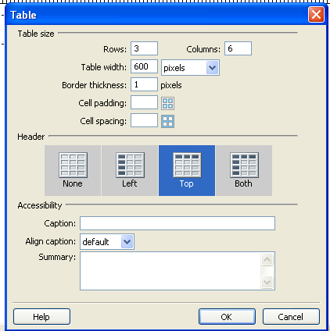
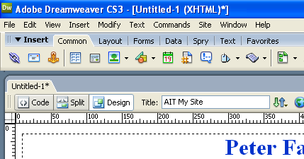

- Insert a table 600 wide 3 Rows by 6 Columns

- In the first table type Task 1

- Colour the background to suit your taste
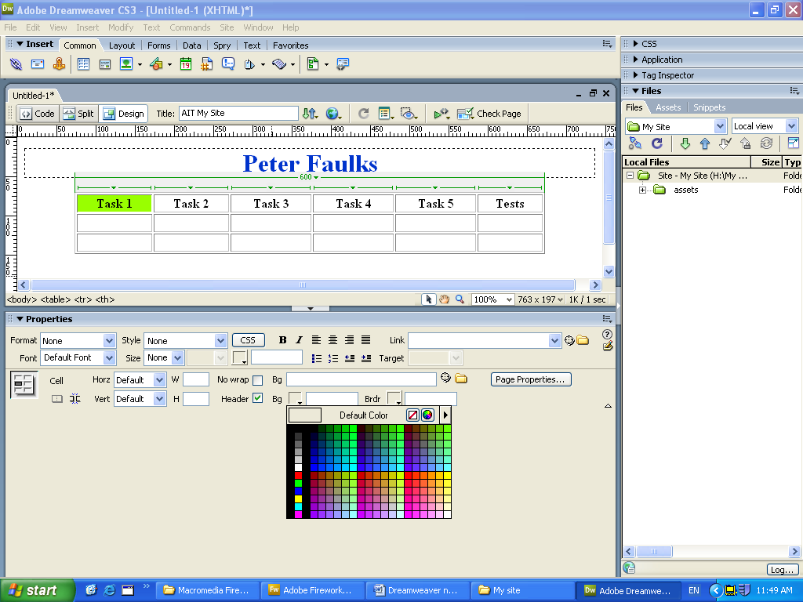
- Type the remaining cells as shown
- Ensure you have a copy of your Camera essay in your workspace
- In Column 1 Row 2 type Camera Essay
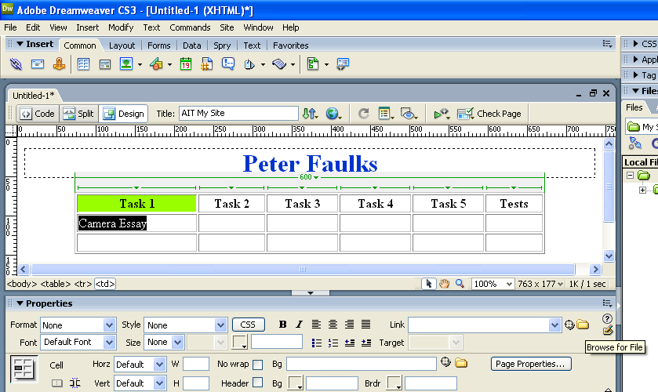
- Highlight the text and click on link and folder (Browse for File)

- Locate your file and the link should have a blue underline
- Centre the link in the cell then add links to all your work so far in the appropriate cells.
- At the bottom of the page insert an animated email gif that you found on the internet
- Type at the side Contact Me
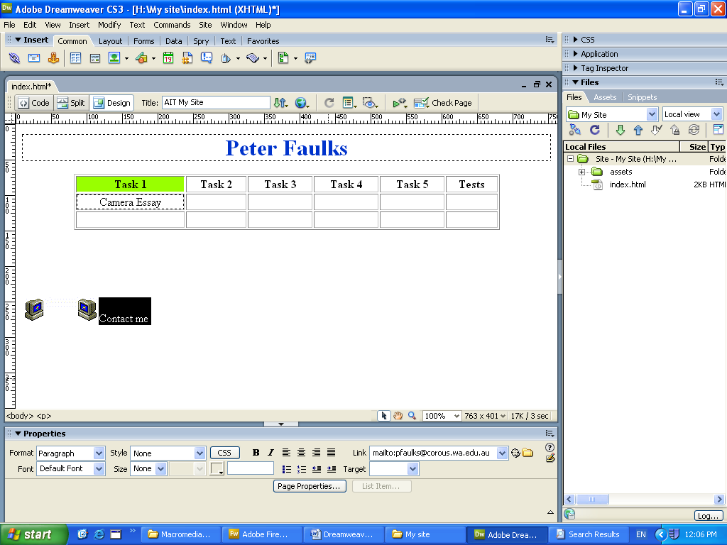
- At the bottom of the properties window in the link type mailto:your@emailaddress i.e. pfaulks@corpus.wa.edu.au
- In the page properties window change your background to suit your taste

Congratulations you have made your first web page

We will now make some rollover buttons for our task items

- Open Adobe Photoshop
- Make your page size A4 with transparent background
- Select a font and type your name
- Select a colour for the font or a background that you like
- Save this (Right Mouse Click) as name.jpg
- Return to Adobe Photoshop and create a button size
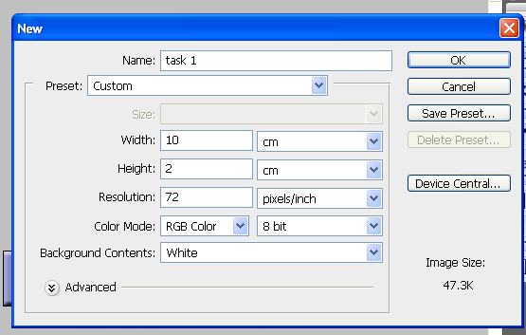
- 5cm by 1cm

- Fill this with a colour of your choice

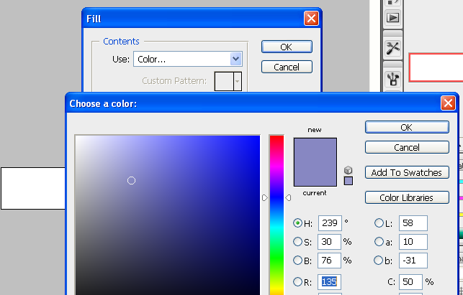

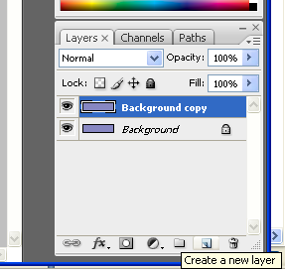
- Duplicate the background layer drag the locked background to the Create a new layer icon
- With the new layer selected From Layer click on Layer style and make this layer Bevel and Emboss…
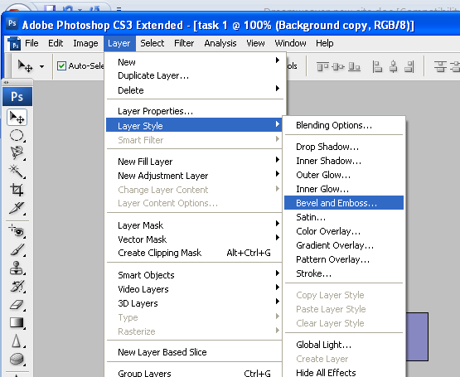

- Use the text tool and type Task 1 in a colour that you think compliments the
- Crop the button and save as task1.jpg

Save this to you site folder
as home2.jpg
Repeat this process making five sets of buttons (ten different graphics).
Set 1 = HOME button home1.jpg home2.jpg
Set 2 = Page1 button Page1a.jpg Page1b.jpg
Set 3 = Page2 button Page2a.jpg Page2b.jpg
Set 4 = Page3 button Page3a.jpg Page3b.jpg
Set 5 = Contact button Contact1.jpg Contact2.jpg

- Go to Dreamweaver and make a table 1 row by five columns leave Border at 1 to show a border (Border 0 = no border - Border 5 = thick border)
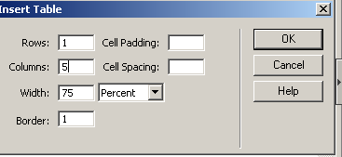
- Click in the first cell and from the menus bar (top of screen) select Insert
- Click on Insert interactive images – Rollover Image

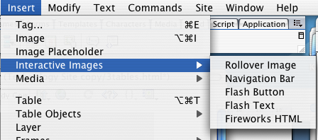

- Title this home

- Browse to the first image (home1.jpg)

- Then click Browse… to add (home2.jpg)

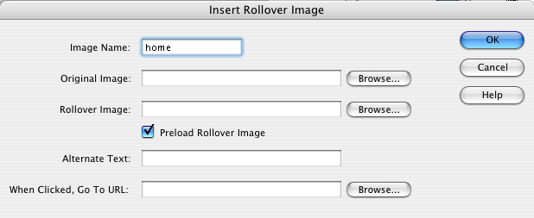Click O.K. and your first rollover button has been inserted.

- Click in the next cell and insert page1

- Repeat for all pages and the contact rollover.

- Save your file and test your rollovers (Preview in Browser) in the I explore browser

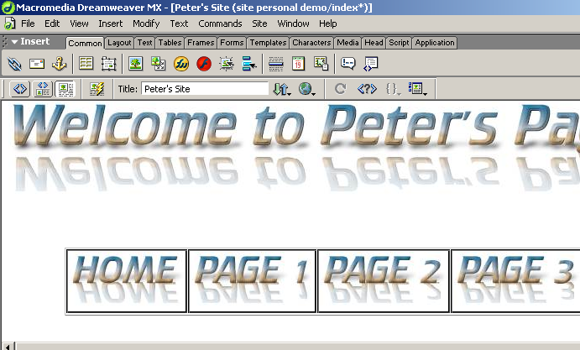

Once you have created your rollover buttons click back in Dreamweaver and insert the links
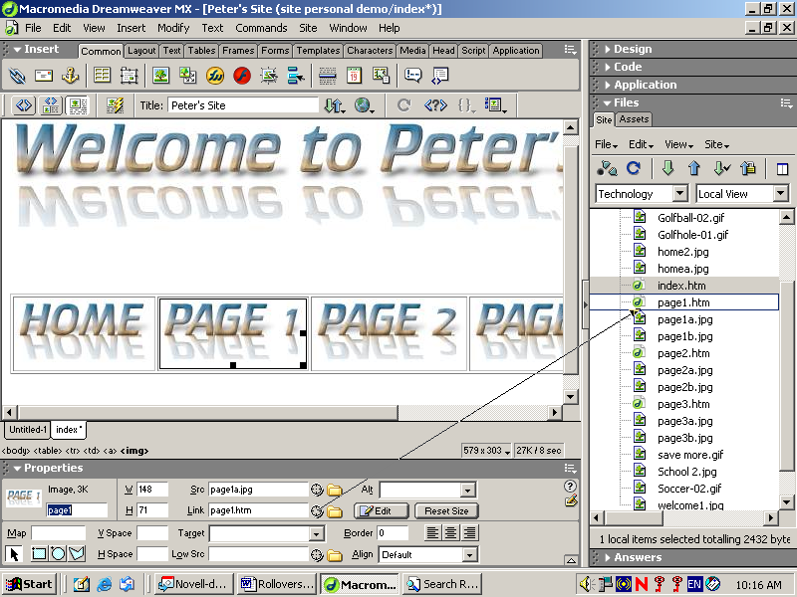

Use the point to file for each link.

For the contact button your link will be: (your name)

mailto:

Check that all the links work and save you work.

Select all the table including the buttons and copy them to each page

